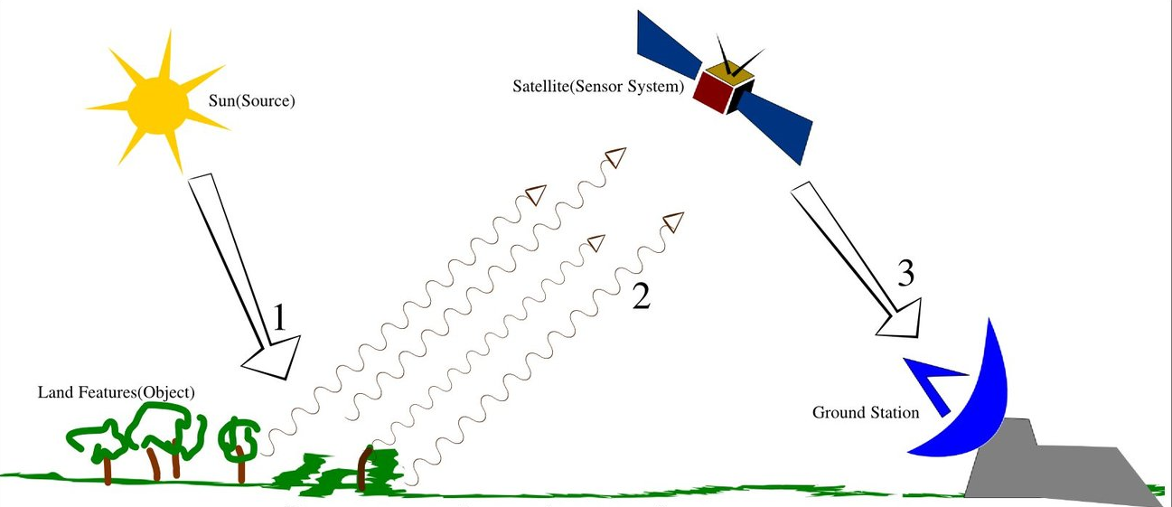

Land Object

Ground Station

Sun (Source)

Satellite (Sensor System)